Derek Wang
– Junior
– Comp Sci-BS
– Expected Grad. Date Fall 23 or if missing classes then Spring 24
Current – Fall 22
Class | Skills | Credit Hours
ITSC 2600 | Introduces the computer science program and develops a student's identity and career preparedness. | 2
ITSC 1213 | Advanced topics in Java including version control, use of debuggers, class design, aggregation and association, exception handling, generic and abstract types, inheritance, polymorphism, interfaces, and abstract classes. | 4
Total Credit Hours: |  | 6

Spring 23
Class | Skills | Credit Hours
ITSC 2214 | A study of the theory and implementation of abstract data types (ADTs) including stacks, queues, and both general purpose and specialized trees and graphs. | 3
ITIS 3130 | An introduction to methods and practice of human-centered design for interactive systems. Topics include: design principles, need finding, design prototypes, and evaluation of interaction designs so that interactive systems are compatible with human capabilities and expectations. Students learn to work in design teams and write project reports. | 3
ITCS 3160 | Logical and physical database organization, data models, design issues, and secondary storage considerations. Emphasis on actual participation in the design and implementation of databases. | 3
MATH 1241 | Designed for students majoring in Mathematics, Science, or Engineering. Elementary functions, derivatives and their applications, introduction to definite integrals. | 3
Total Credit Hours: |  | 12

SUMMER 23
Class | Offered | Credit Hours
ITSC 3146 | * | 3
MATH 1242 | * | 3
ITSC 3181 | * | 4
ITSC 3155 | * | 3
Total Credit Hours:
Notes: Need to be a 3 or 4 credit class

FALL 23
Class | Offered | Credit Hours
MATH 2164 | * | 3
ITSC 2175 | * | 3
ITCS 3153 | * | 3
ITCS 4232/4238/4155 | * | 3
ITSC 2181 | *
Total Credit Hours: |  | 12 +?
Notes: Need 8 credits. Graduate if Possible else Spring 24

Spring 24
Class | Offered | Credit Hours
STAT 2122 |  | 3
?? |  | 4
Total Credit Hours: |  | 7
Notes: Only if not enough credit due to missing classes for SUMMER 23 and FALL 23.

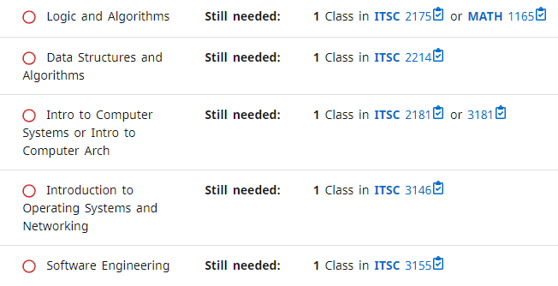
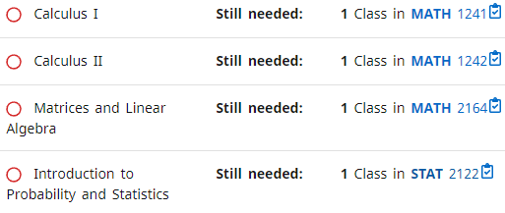
ITCS 4111
ITCS 3120
ITCS 4123
ITCS 4124
ITCS 4150
ITCS 4151
ITCS 4152
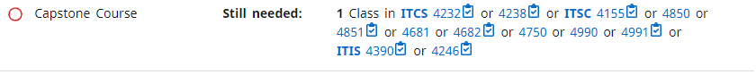
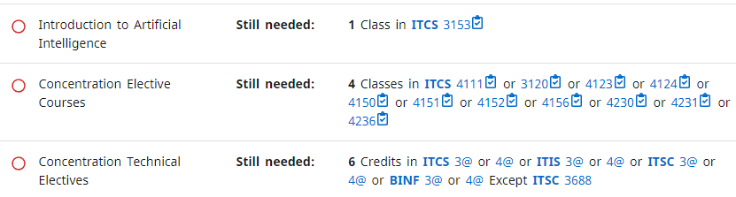
https://catalog.charlotte.edu/preview_program.php?catoid=32&poid=8543

